BIG MOUNTAIN PROJECT REPORT
Big Mountain Resort located in Montana offers access to 105 trails by 11 lifts, 2 T-bars and 1 magic carpet. It has already installed an additional chair lift which increases the operational costs by $1,540,000 this season. The expected number of visitors over the season is 350,000 and, on average, visitors ski for five days. The resort operates within a market where people pay more for certain facilities, and less for others. BMR wants to find the best premium ticket pricing model based on its facilities and competitors. Its current ticket price is $81.00.
Based on the given data we built our model which gave the best 4 features -fastQuads, Runs, Snow Making_ac, Vertical_drop- for ticket prediction. We compared BMR position among all resorts for these features.
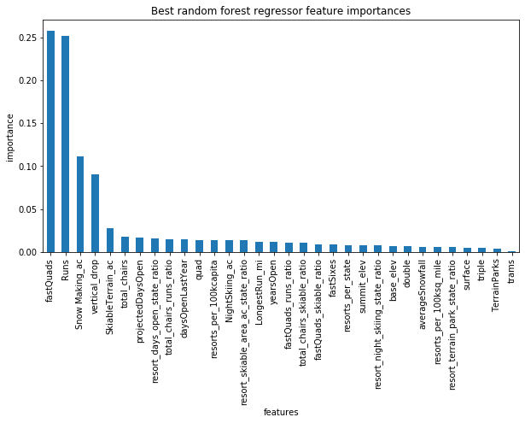

As you can see in the below graphs of 4 features, BMR with the vertical red line, has the high up positions among its competitors.
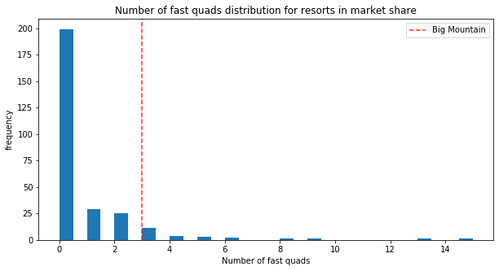
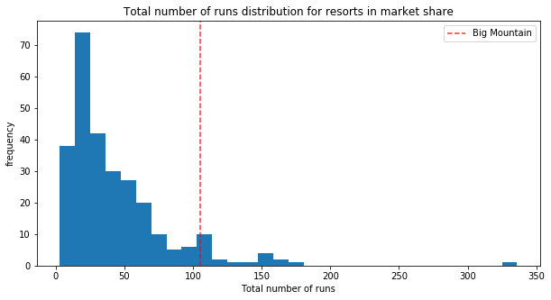

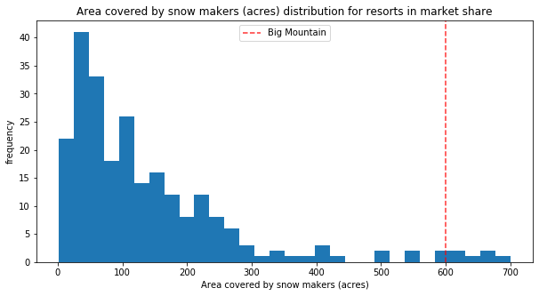
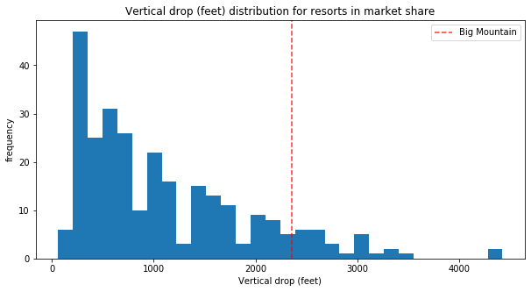

Although BMR’s current ticket prices are higher within Montana and among other states, due to our position in these features, our model predicts ticket prices can be increased up to $94.22.
Recommendations:
We reviewed the proposed 4 scenarios for either cutting operational costs or increasing revenue from ticket prices. According to our modeling the most profitable scenario is adding a run, increasing the vertical drop by 150 feet, and installing an additional chair lift. This increased the ticket price by $1.99 and revenue by USD3.5M. We know that cost of lift installation is ~USD1.5M. Therefore the revenue increase will cover the installation and operational costs.
The stakeholders should come up with new options, such as reducing the operational costs without affecting the prices. From the 1st scenario we know closing 1 run wouldn’t affect pricing but would reduce the operational cost. According to our 2nd scenario, increasing the vertical drop by adding run would increase the ticket prices. But this would also increase the operational cost. So I would recommend stakeholders to review to closing the least used run to compensate the cost of 2nd scenarios additional run.
Our data had many missing values and also the operational costs were not in our data set. These deficiencies affect the accuracy of our model. To improve the model performance, knowing the operational costs of snowmaking, staff, electricity and maintenance would be useful.
Business should also focus on targeted marketing based on customers demographic and demand data and advertising by highlighting the top featured facilities, like highlighting the increase of vertical drop and high number of chairs that would reduce lift wait times.

